DONA TION FORM

Donation: _______________________________________________ Value: __________________________ Description of Item: _______________________________________________________________________ Special Conditions: ________________________________________________________________________ Donated By: ______________________________________________________________________________ Description of Item: _______________________________________________________________________ Special Conditions: ________________________________________________________________________ Donated By: ______________________________________________________________________________ Phone: _________________________________ Best time to reach you: _____________________________ Please pick up (date / time / location): ________________________________________________________

P A Y MENT INFORMATION

Name: ___________________________________________________________________________________ Address: _________________________________________________________________________________ City / State / Zip: __________________________________________________________________________ Phone / Email: ____________________________________________________________________________
❐ Tournament Fees Enclosed $ ______________________
$135 per golfer, $150 after August 31st (includes golf, golf cart, food & drink on the course, dinner, and auction)
❐ Sponsorship $ ______________________
❐ Dinner - $50 per person donation $ ______________________ Bring a Guest for Dinner and Auction
- I cannot attend, but want to support $ ______________________ support Forestville Youth Park

Please charge my credit card ❐ VISA ❐ MASTERCARD

Card # ___________________________________________________ Exp. Date _______________ 3 Digit Code _______________ Signature ___________________________________________________________________________________________________

Thank you for your Support!

PLEASE RETURN YOUR PAYMENT & COMPLETED FORM TO:

Forestville Youth Park • P.O. Box 357 • Forestville, CA 95436 www.forestvilleyouthpark.org
FOR MORE INFORMATION: Scott Brown – scottemll@yahoo.com -707-293-0700

Forestville Youth Park is 501(c)(3) non-profit organization; all donations are tax deductible (Federal Tax ID number 94-6270781).

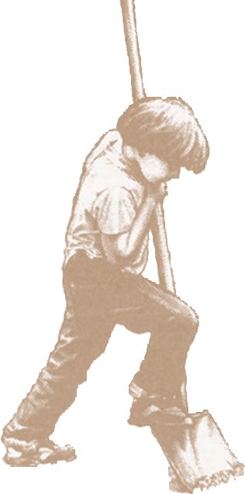
13th Annual FORESTVILLE YOUTH PARK OUTHOUSE CLASSIC GOLF TOURNAMENT

Friday, September 7th, 2018 | 1:00 Shotgun Start

At the beautiful Windsor Golf Course!
SCHEDULE OF EVENTS
11:30 Registration & Warm Up 12:15 Putting Contest
1:00 Shotgun Start
6:00 Dinner, Awards, Auction & Raffle
$135 per Golfer; $150 after August 31st, 2018
Enjoy dinner, live and silent auctions immediately following at Charlie’s Grill.

Name: ___________________________________________________________________________________ Address: _________________________________________________________________________________ City / State / Zip: __________________________________________________________________________ Phone / Email: ____________________________________________________________________________

❐ 4 PLAYER TEAM | $540

4 Dinner Tickets | Paid by August 31st After August 31st $600
❐ INDIVIDUAL PLAYERS | $135

1 Dinner Ticket | Paid by August 31st After August 31st $150
1. __________________________________________
2. __________________________________________
3. __________________________________________
4. __________________________________________

❐ DINNER ONLY | $50

S PONSORSHIP LEVELS & P A CKAG E S

❐ CART SPONSOR | $1250

Logo & signage displayed on tournament carts 4 Dinner Tickets
❐ HOLE SPONSORS | $500

Company banner displayed at hole Sponsorship non-exclusive
❐ DINNER SPONSOR | $500

Company logo displayed at Awards Dinner Auction
❐ EXECUTIVE GIFT SPONSOR

Donate executive logo gifts for golfers, Auction or raffle items

Forestville Youth Park • P.O. Box 357 • Forestville, CA 95436 www.forestvilleyouthpark.org
FOR MORE INFORMATION: Scott Brown - scottemll@yahoo.com - 707-293-0700

