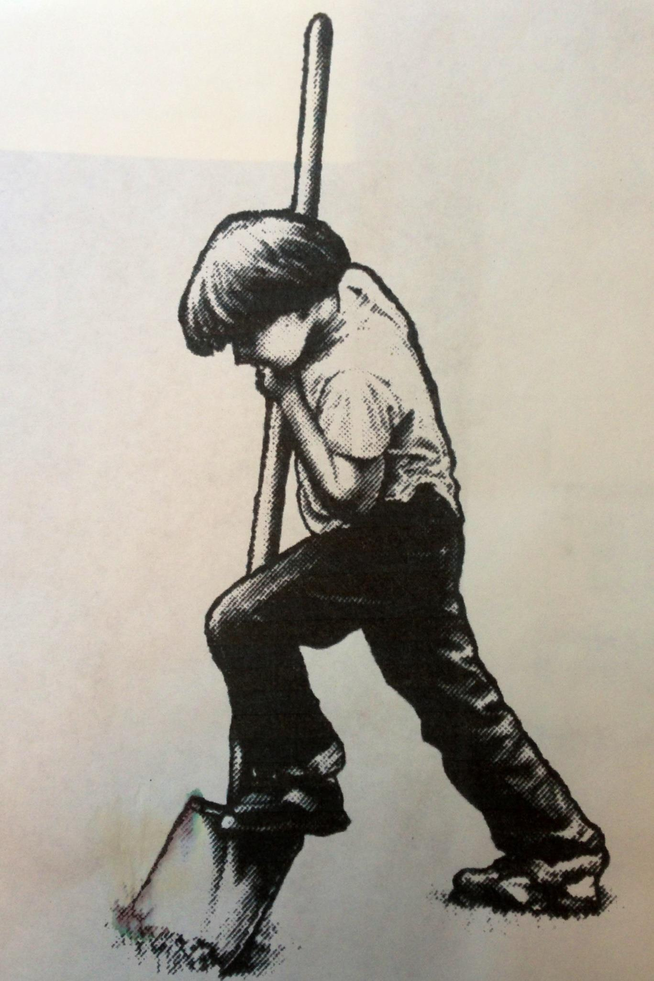

**Forestville Youth Park’s**

# Annual BBQ, Parade and Carnival

June 2nd and June 3rd 2018

**VENDOR APPLICATION**

Name: ______________________________ Phone Number: ______________________

Address: ________________________________________________________________

City: ____________________________ State: _____________ Zip: ________________

E-Mail: ______________________________Fax Number: ________________________

Resale Number: __________________________________________________________

Description of items to be sold:

(Please provide photos of your booth and of items to be sold if this is your first time participating)

Sorry, no food vendors will be accepted.

________________________________________________________________________

________________________________________________________________________

Fees: $75.00 for one day or $100.00 for both and must be paid in advance to reserve a space. Email confirmation will be sent upon receipt. **30-day notice of cancelation prior to event needed for a full refund of space fee. No refund will be given after this date.**

**For applications sent after May 24th**,**the space fee will be $100 for one day, $150 for two days, if space is available.**

Set-Up: Booth must be set up between the hours of 7:00am to 10:00am Saturday morning.

Prior arrangements can be made for Friday setup.

Vendors are responsible for their own booth, and clean up!

\***Please check in with the Vendor Coordinator prior to setting up.**

Utilities: Electrical outlets are NOT available.

Hours: Booths must remain open until 5pm. You may stay open later if you wish.

Site: Site sizes are approximately 10’ x 10’, larger sites can be accommodated (additional fees apply).

***Please make checks payable to: Forestville Youth Park***

*Mail with signed regulation and application form to:*

**Shawn Roades**

**Forestville Youth Park**

## P.O. Box 943

**Forestville, CA 95436**